|  |  |  |  |  |  |
| --- | --- | --- | --- | --- | --- |
| Date | 22-Sep-22 | | | Tester Name | Shahabuddin Syed |
| Environment | Penfax - Test | | | Login used |  |
| Operating System | Select OS | Version: | Update: | | |
| Software Used | Select Software | Version: | Update: | | |
| Select Software | Version: | Update: | | |
| Release version | 22.3.0 | | | | |
| Title | E21.07 | | | | |
| Test Type | Regression | | | | |
| Test Scenario | Process a Payment for late fees | | | | |
|  |  | | | | |
| Expected Results |  | | | | |
| Pass/Fail | Pass | | | JIRA# | N/A |

Describe your steps with screenshots:

Search for any Employer in the PEPP Plan who has outstanding fees

Click on Accounting  
Remittance Management

Add Remittance

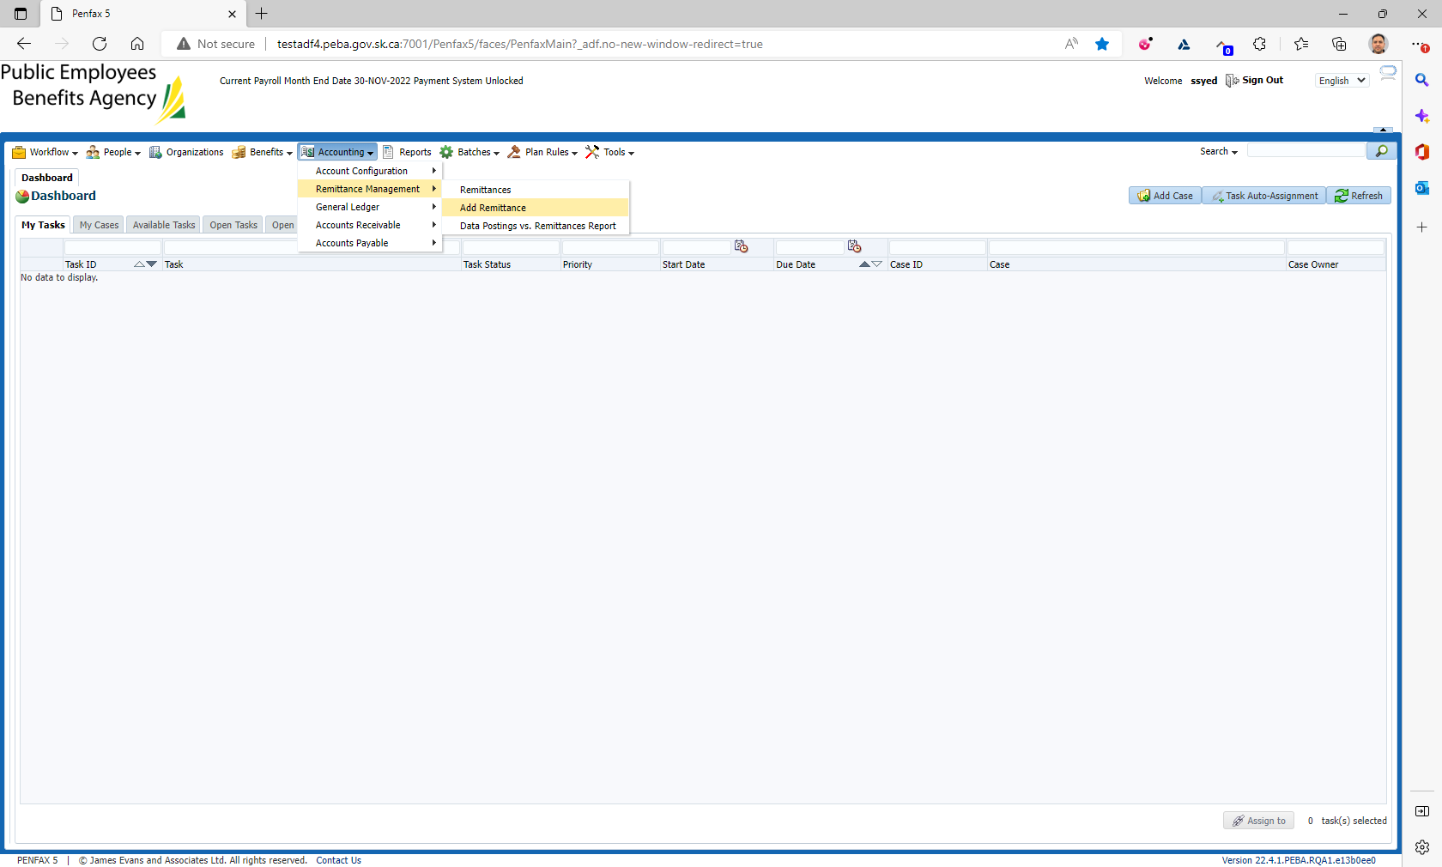

Under Plan Select PEPP  
Under Receiver From select the employer from the precondition  
Remittance amount enter the amount of the fee $25.00  
Select a receipt date  
Input a cheque number  
Input a note as payment for late fee dated(and then put the date of when the late fee was charged.  
Click Save

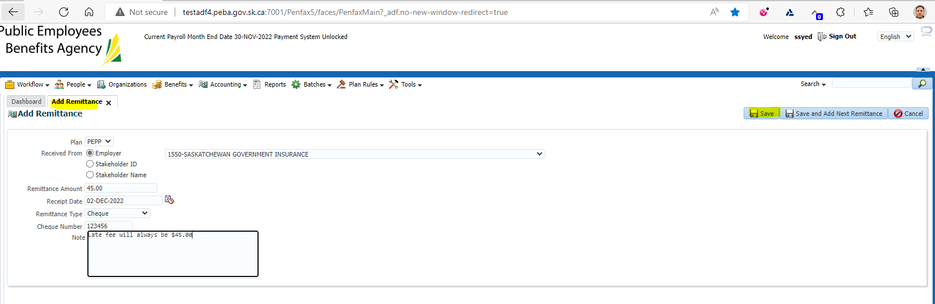

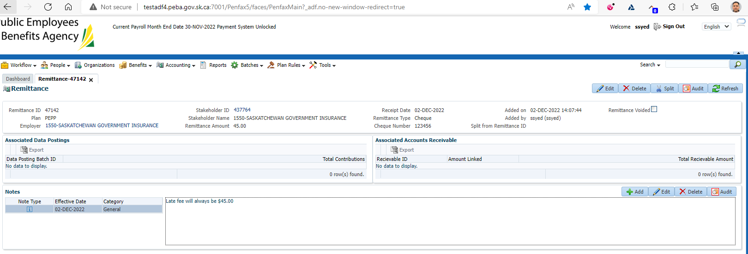

Click on Accounting   
Then Accounts Receivable  
Then Receivables,

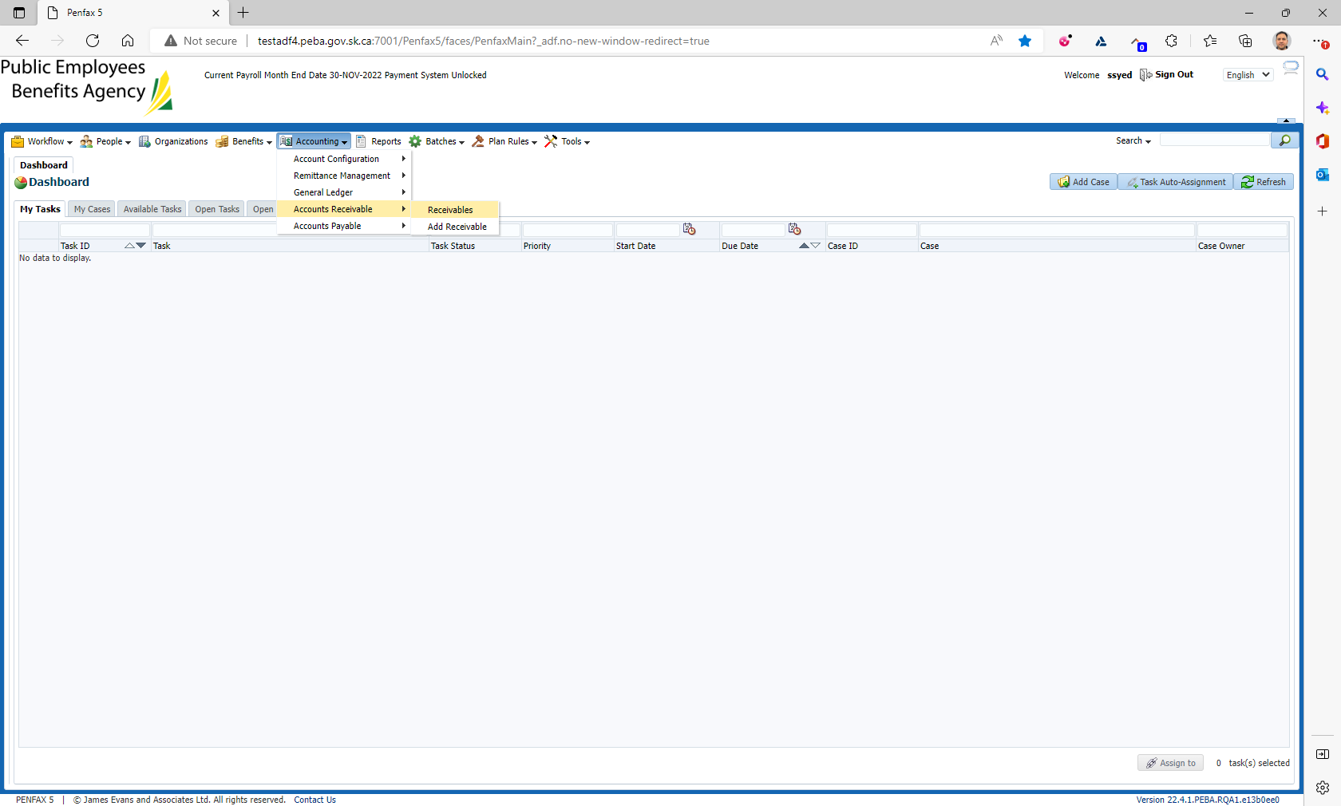

Search for the fee from the precondition  
Click on the Receivable ID

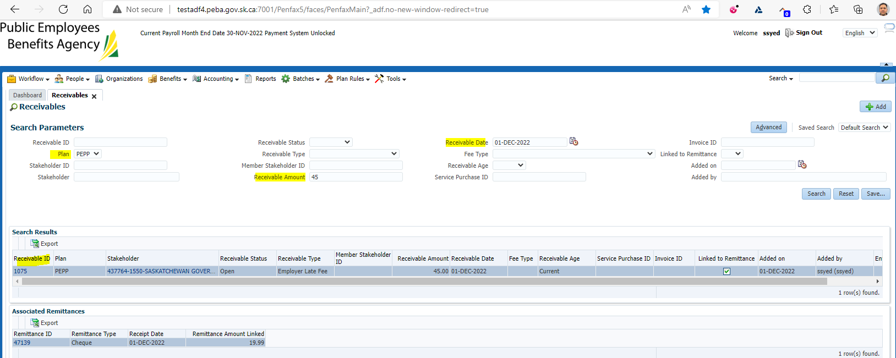

Under Remittances link to Receivable Click the Add button

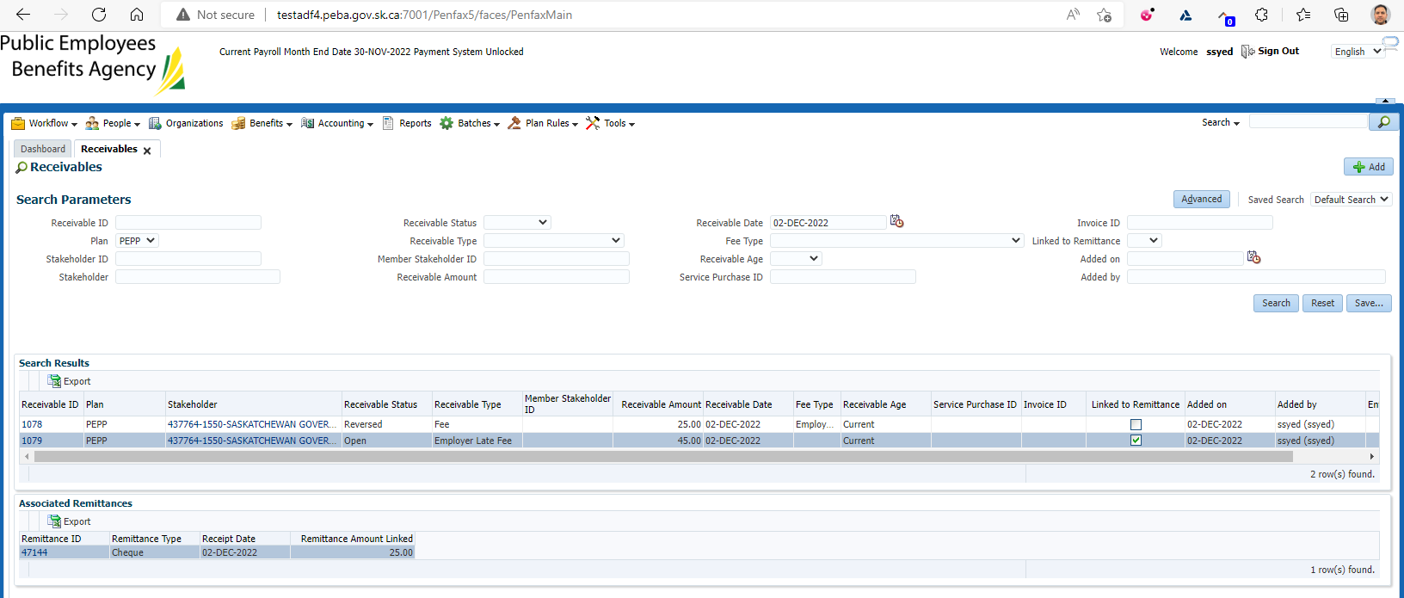

Under Remittance ID select the ID from Step 2  
Remittance amount to link input the same as in step 2. $25.00  
Click Save

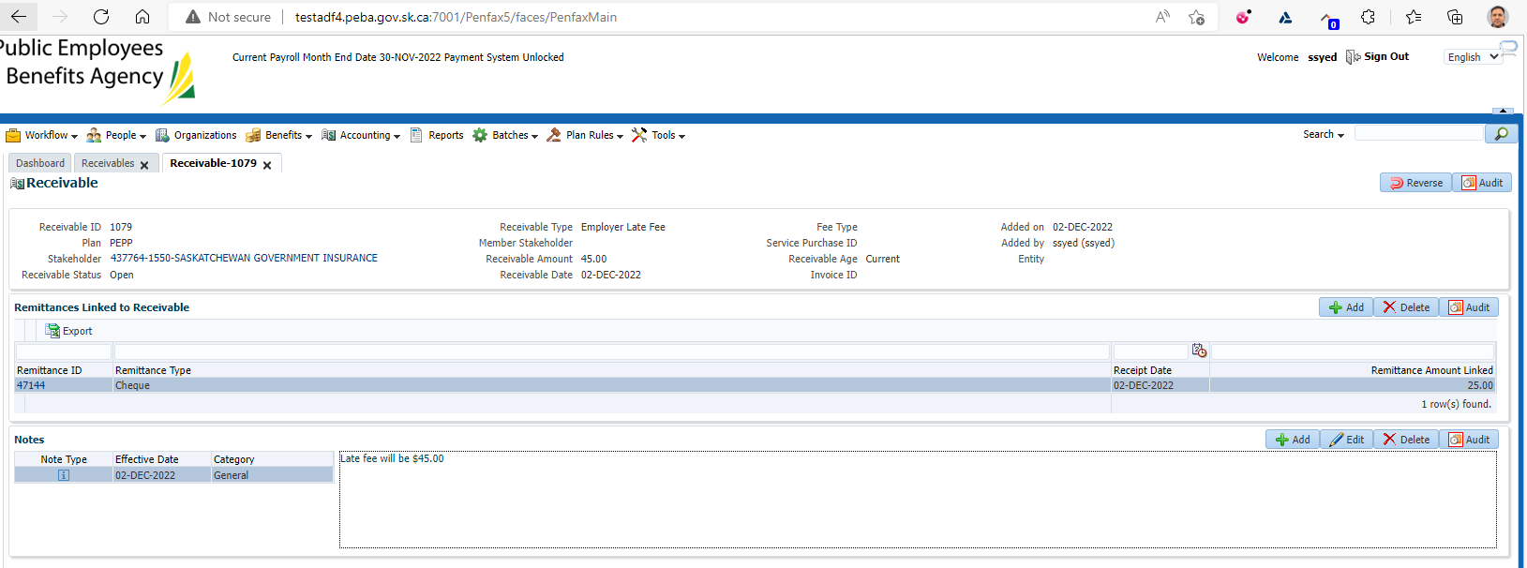

Click on Accounting   
Then Accounts Receivable  
Then Receivables,  
Search for the account you just processed the payment against.

